# Report for Jason Peele (2024-10-01 to 2024-10-31)

Average Bat Speed: 53.81

Average Rotational Acceleration: 6.64

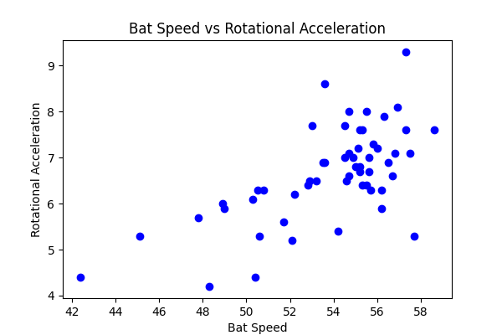

## Comments

Add comments here...